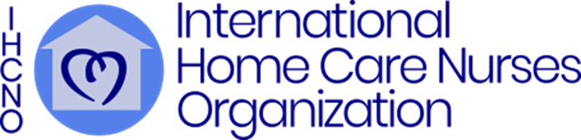

***Research Funding Opportunity***

***Marilyn D Harris Research Grant***

The grant will provide $2,000 (U.S. dollars) to support your study that is planned or in progress. The proposal may describe a literature review, project, or research to enhance home care nursing. Please review the application for additional instructions.

Eligibility is for Registered Nurses with a doctorate degree or current enrollment in a doctoral program who are studying an aspect of home care nursing. The funding is available to an individual researcher or a member of a research team.

The grant overview and application materials are available on the IHCNO website <https://ihcno.org/research-page/>.

**Application Due Date is September 30, 11:59 pm EST**

**(New York City, USA)**

~~~~~~~~~~~~~~~~~~~~~~~~~~~~~~~~~~~~~~~~~~~~~~~~~~~~~~~~~~~~~~~~~

The International Home Care Nurses Organization is a (501) (3) nonprofit organization. Consider a contribution to support the mission of the IHCNO to communicate, connect, and collaborate with home care nurses around the globe, creating an international community of nurses who spur one another to excellence in home care nursing practice.

Please go to the IHCNO website at ihcno.org/join-us to become part of the IHCNO network and receive emails about events and other information. There is no cost to join the IHCNO network.

1 Shepherd’s Way, Suite 207, Warminster, PA 18974- 4203

IHCNO.org